* **Config** (trong file @configuration
  + Define messageSource()

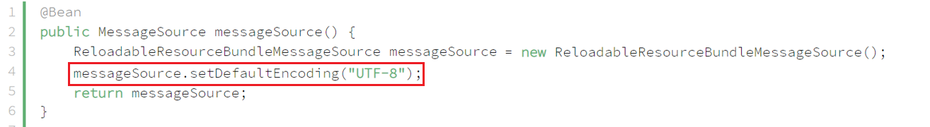

* + Define LocalValidatorFactoryBean

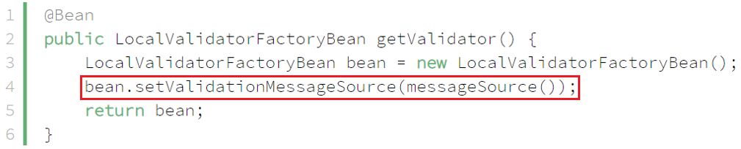

* **File messages_vi.properties**

Trên menu Edit chọn Set encoding và chỉnh về utf-8

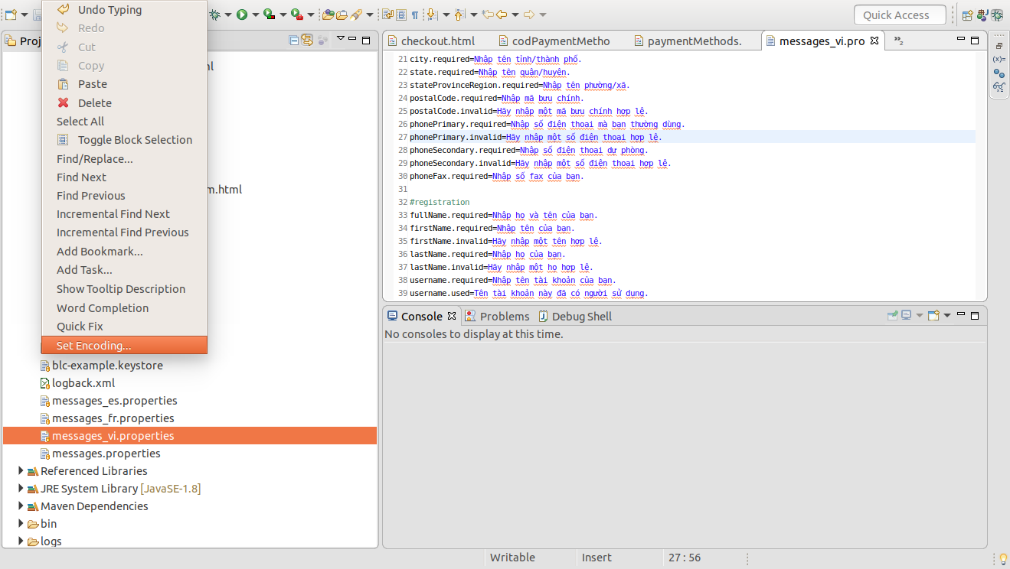

* **Reference**

<https://daynhauhoc.com/t/viet-tieng-viet-trong-file-properties/96160/3>

<https://www.baeldung.com/spring-custom-validation-message-source>